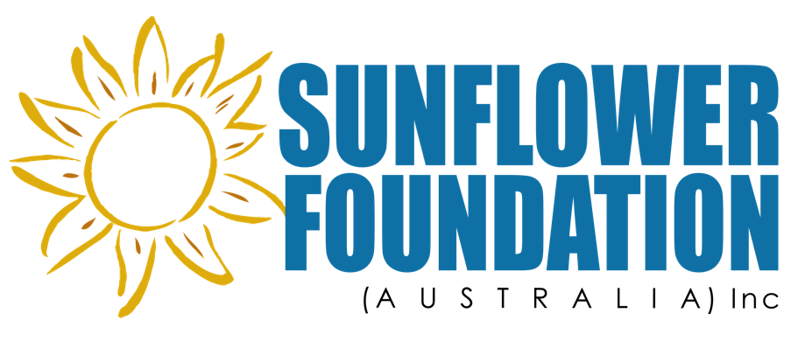

Annual Report 2015

Sunflower Foundation (Australia) Inc. 3
Purpose 3
Intention 3
Our Funding Model 3
Overview 4
Leadership 4
From the President 4
2014-15 Grants Report 5
The Aids Orphans Rescue Program (TAORP), Uganda 5
El Shaddai Ministries Trust (EMT), India 6
Heshima Kenya 7
Fundraising 8
Events 8
Donations 8
Other Fundraising 8
Financial Report 8
The Sunflower Foundation (Australia) Inc. 8
Statement Of Income & Expenditure For Year Ended June 30, 2015 9
Sunflower Foundation Public Fund 11
Organisational Information 14
Contact Details 14
Social Media 14
Regulatory 14

Sunflower Foundation (Australia) Inc.
The Sunflower Foundation (Australia) Inc. was the first Australian micro-organization established to educate girls in developing communities. It is the only one to hold full Overseas Aid Organization Deductible Gift Recipient Status (OAGDS) and its accompanying Deductible Gift Recipient Status FROM THE ATO. That is, The Sunflower Foundation (Australia) Inc. has been gazetted by Treasury as an approved Overseas Aid Organization and registered with the Australian Charities and Not-for-profit Commission. The Foundation is national, being registered to fundraise in every state and territory.

Purpose
Bearing in mind that girls cannot be educated without addressing both the quality of said education and the barriers to it, the essence of our mission is to educate and empower girls and young women in developing countries. In this context, empowerment means:
- Completion of secondary education with the literacy (in their national language) and numeracy skills essential to earn a living and support a family;
- The social skills to contribute to the empowerment of other girls and the development of their countries;
- The knowledge and judgment to make informed decisions about their health and sexual life.
- The ability to live longer, healthier lives. For example, educated Tamil women’s life expectancy increases 25 years to 67. Girls who complete secondary education avoid child marriage and child/early teen pregnancy. Their risk of HIV/Aids decreases 12% for every year of secondary schooling. Educated girls are less vulnerable to trafficking. Therefore they are not among the 4 million girls “missing” due to premature death each year.

Intention
Rather than speak of vision, we prefer to speak of intention. In the coming weeks, we will decide our goals and strategy for the next five years. Broadly speaking, these will encompass:
- Our annual target reach, based on a percentage of past years;
- Working to overcome the hurdles that prevent girls obtaining an education.
- Working to ensure that that girls’ education is a good one by establishing a flexible, best practice teaching framework that schools and teachers can adapt to their context. Education in some developing countries is in a parlous state, with schools having in excess of 200 students per class; with untrained teachers, without teaching resources;
- Setting big goals for fundraising through philanthropic grants, corporate partnerships and sponsorships and donor giving circles.

Our Funding Model
We partner with local, non-government organisations (NGOs) and charities⎯the grassroots people who know what is needed and offer utmost efficiency⎯via an annual grants process. We only grant funds to registered charities and NGOs, and we have approved policies in place to ensure grant monies do not go to terrorist fronts or fake charities. Funds are sent only to authenticated accounts. Full disclosure of our process is found on our website at www.sunflowerfoundation.com.au.

Overview
This year has been one of both growth and reflection. The Sunflower Foundation (Australia) Inc. recorded its highest turnover. An outcome that needs to multiply if we are to fulfill our purpose and achieve our vision.
Our process and planning for corporate partnerships is on target and our intention is to have two such partnerships by the beginning of the 2016 Financial Year.
Grants were made to The Aids Orphan Rescue Program (TAORP), Jinja Province, Uganda; El Shaddai Ministries Trust (EMT), Tamil Nadu, India; and the Tanzania Women and Youth Development Society (TWYDS), Dar-es-Salaam, Tanzania. Our 2015-2016 grants will reach 15,000-18,000 girls through both academic and community education.

Leadership
The Sixth Annual General Meeting of the Sunflower Foundation (Australia) Inc. was held on 13 October 2014. The meeting elected Kim Power, PhD, President; Paul Power, PhD, FAPS, Public Officer; Katarina Radonic, Vice President; Katrina Steel BA, CELTA, Dip. Ed Treasurer; Nadine Armstrong, Sally Hsueh-Chih Lai PhD, Gail McGillivray. Anne-Marie Carey, Shalini Gupta and Christine Marcus were co-opted during the year. This Committee had strong skills in educational policy and practice, policy-making, gender studies and event management and marketing. It also had strong support from volunteers, Helen Scotts; Moira Rayner LLB; Martina Donkers; Jade Palmer; Ragini Singh, Kiran Bhadapelli, Peter Kemp, Giriraj Vijayaraghavan; Raul Lavinia and, Eva Grecco. Unfortunately, work demands brought about the resignations of Katarina Radonic, Katrina Steel, Sally Hsueh-Chih Lai. and Gail McGillivray. What they have accomplished this year is amazing and the Foundation is indebted for the time they have so generously given, as it is has no paid staff.
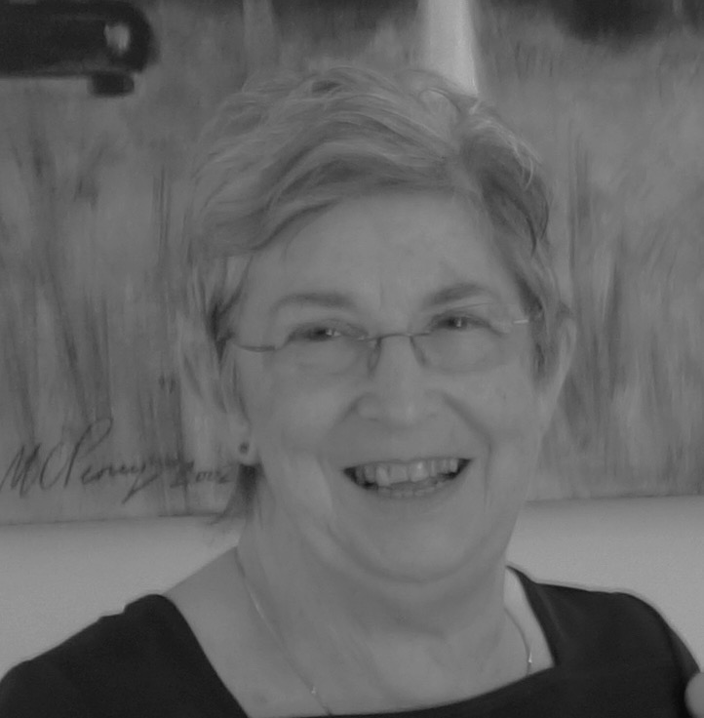
The Foundation is extremely fortunate in having a strong group of committee nominees for 2015-2016 year, who are passionate about the cause and committed to growing the Foundation.

From the President
As co-founder and President, it has been my passion, challenge, frustration, and joy to bring The Sunflower Foundation (Australia) Inc. to its current status. We are proof that from little things, big things grow. We began with the intention of educating one girl each year via a family trust to honour my mother. By the end of this financial year, our donors will have contributed to the education of thousands of girls. Our increasing growth and reach has continued almost exponentially, so much so, we are outgrowing our home office space.
The skilled professionals forming our 2016 committee share our passion and, hopefully, will be willing to don Paul’s and my mantles in the near future. A growing, vital organization needs a President to match. Pro bono space in Richmond or the CBD would benefit us greatly.
Two strategic planning workshops were held to reaffirm our purpose, articulate our values and beliefs, and identify our opportunities as a prelude to developing our five year plan. A Strategic Planning Subcommittee was established to formulate this plan to enable us to fulfill our intentions, so that we do not just educate girls and young women, but work to ensure that that education is a good one and that the hurdles that prevent them obtaining an education are overcome.

2014-15 Grants Report
Every year grant applications increase. In 2015 we could only fund 10% of the applicants. As we have longer-term impact reports now available, we have focused on these and 2015 grants will be reported on in the next annual report.

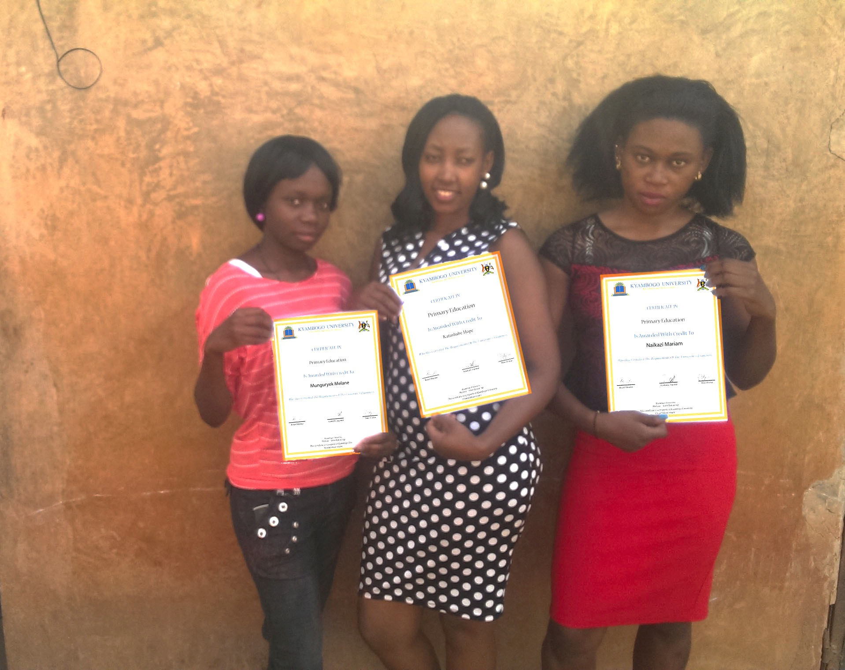
The Aids Orphans Rescue Program (TAORP), Uganda
L-R: 2014 Graduates: Mukungurye K. Melane, Hope Katushabe, and an unnamed graduate
Like The Sunflower Foundation, TAORP has expanded its scope beyond its original intent. With carers of AIDS orphans now receiving support, they are dedicated to improving education in rural Uganda and to promoting the role of women in society through their Forum on Women in Democracy. 2014’s grant built on that of 2013, which equipped a Rural Education Centre with computers and peripherals. This Center enables unqualified preschool and primary teachers to acquire computer literacy and complete professional studies online, in a government recognised institution, whilst they are teaching in rural schools. It also offers refresher courses for graduate teachers. The University of Kyambogo created, audited, and granted graduates a Rural Education Certificate. In addition, through an international educational support program, students received mentoring from qualified teachers in developed countries.
The first cohort of seventy-eight students began in 2013, two thirds of which were young women. It was originally planned that they would graduate in one year. However, the need to become computer literate before beginning the course, and the fact that, even after two grants, the Centre had only 25 computers, meant that students took two years to graduate. In future, each intake will be restricted to thirty students.
In 2014, forty-two of the original fifty girls graduated and received their certification and are now Government registered. The attrition was due to several of the normal barriers to girls’ education: husbands refusing to allow their newly wed wives to continue their studies, pregnancy, and family opposition.
My uncle works at a school in town. I told him about this when we had just begun in 2013, he promised that when I complete training he will take me to work for the school for a better salary. I, however, want to stay and contribute to the purpose first as it grows because it’s the reason why I have been trained for free… I also thank the foundation that sponsors this project. I just see the poster there but I really thank God for their good heart and enabling them do this for us.
Mukungurye K. Melane

El Shaddai Ministries Trust (EMT), India
Parangani Tuition Centre/Dairy Farm
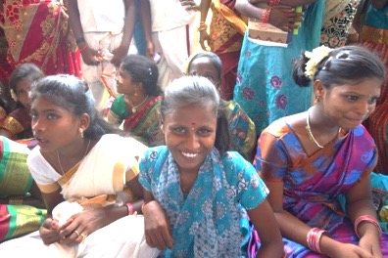
The funding for 2014-5 had the same goals as our previous two grants: To improve the education of Dalit children, especially the girls. The Dalits, formerly the Untouchables, are the poorest of the poor in India. They are discriminated against in every walk of life. They do not speak Hindi, so when the children attend school they are disadvantaged and fall behind. Illiterate parents cannot help. The tuition centres we fund, plus the livestock programs for mothers and carers, make an education possible.
In Parangani, the nucleus of a dairy herd was purchased. Mothers and grandmothers were trained by an agricultural scientist to care for and breed the herd. Milk products not only provide badly needed nutrition for families, the sales of dairy products fund the children’s ongoing education. Seventy-three girls benefited in this first year. The girls are empowered to take responsibility for their progress, shown how to improve their exam techniques, given a confidence boost and inspired to excellence, in addition to the academic support needed to improve their grades. They are also offered growth enhancing activities and experiences that promoted academic, personal, social, and recreational development. In addition to the academic results below, the impact of the grant was:
- Fewer child labourers;
- An increased interest by girls in the after school tuition programs, because of the supportive, educational environment;
- Strong parental support for the after school tuition programs, particularly from working parents, because of the safe and supportive adult-supervised environment.
EMT has sent us not only the data from Parangani, but updated impact reports from our previous co-projects.
Projects | Nullavour |  | Paravour |  | Parangani
Impact | 2012-13 Grant |  | 2013-14 Grant |  | 2014-15 Grant
Beneficiaries | 86 |  | 78 |  | 73
Results in % | Before | After | Before | After | Before | After
Dropout rate | 30 | 0 | 25 | 0 | 12 | 0
Attendance | 50 | 95 | 65 | 95 | 75 | 100
Language & communication | 20 | 75 | 40 | 90 | 75 | 100
Academic Performance | 45 | 90 | 55 | 90 | 20 | 85
Health & Hygiene Ed. | 20 | 80 | 25 | 85 | 20 | 85
Women’s income as % of household’s | 25 | 80 | 40 | 85 | 25 | 75
Girls are staying at school and their academic scores have improved exponentially.
One grandmother, who supports her granddaughter, wrote to us about the difference that the program has made in her village:

Not only was my granddaughter’s wish fulfilled but our hearts are also content. There are many other citizens in our village who were benefited by this. I heartily thank Sunflower Foundation, and we wish you to continue this and encourage all people. Thanking you, Best regards, Muniyamma, Grandmother of Srirathi.

Heshima Kenya
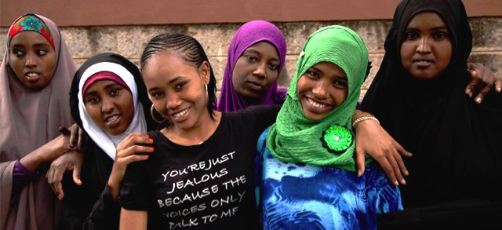
Heshima Kenya serves girl refugees, who are minors without families. Their Girls’ Empowerment Program (GEP) empowers these young women to rebuild their lives and gain skills for self-sufficiency. Academic skill is tested by the Kenyan Adult Education Department, while life skills include human rights, reproductive health, gender violence awareness, community resources and leadership. Expectant and young mothers also receive training in childcare.
These girls have been traumatised by civil or tribal war, abduction, rape, and loss of their families. The GEP offers these girls a uniquely designed, open enrolment Program that allows them to begin when they are ready. While they study, their babies are nurtured in the crèche cum kindergarten where they learn to speak English as well as Swahili. This year, the program exceeded expectations. One hundred and eighty girls were provided with basic education and life skills. Eighteen graduated from the vocational program; seventeen joined the Maisha Collective, which produces beautiful soft scarves and sarongs to sell online, and twelve young women graduated from the Collective and received UN loans to begin their own businesses.
Apart from the acquisition of academic and life skills, the girls’ mental health has improved, as has their self-confidence. Heshima Kenya states that, “The long term impact demonstrates the young women enrolled benefit from the skills and the education they have gained to earn an income, support themselves and their babies and serve as leaders in their communities. This work and these outcomes would not have been achieved without the support of the Sunflower Foundation.”
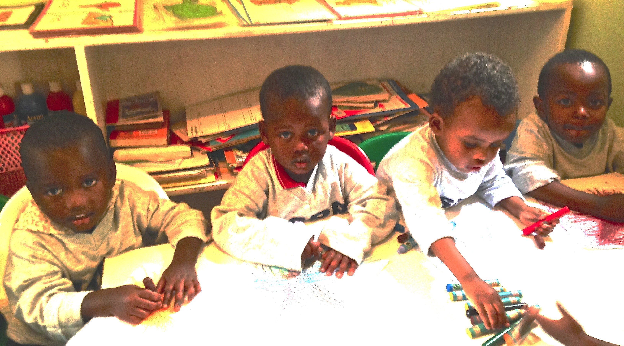
Chantal is typical of many of her fellow students. Chantal is a Congolese refugee who was abducted and raped when she was held captive in a forest by rebel troops. James is the product of that rape. After 6 months tuition, Chantal was one of the top performers in the adult education proficiency test administered by the Kenyan Government. She has emerged as a leader in her cohort, has qualified as a certified tailor, and is a member of the Maisha Collective. Her stipend allows her to live independently with James as she continues her studies, aiming for College.
I love that me and my child have a safe place to stay within the Safe House and that every morning I come for my education, and my child is cared for by people who love and understand both of us. I can concentrate on my education knowing that both of us are safe and have everything that we need. The work is hard but I’m learning very fast and will one day be a doctor. Alice
We are very proud of what we have achieved with our partner organisations and the “ripple effect” will extend these achievements well beyond the original participants.

Fundraising
This is an area where we must improve within the next five years. If we need to rent premises, our annual costs will be between $80,000-100,000.00. Which amount includes an office manager for Work for the Dole staff available if we have premises approved for OHS. That means we need to raise $300,000.00 annually.

Events
Three successful events were held this financial year.
- A Trivia Night at Trinity Community Hall
- A fundraiser held by Tintern Schools’ Social Awareness Group (Now the Poverty Project)
- The inaugural Future Girl Cocktail Party at The Point, Albert Park.

Donations
In addition to those generous supporters who make regular and one off donations each year, we thank those companies who have given us gifts in kind for our social events. Betty McDowell Lingerie, Cellarbrations, Daniel Power Art & Photography, Haigh’s Chocolates, Immerse Winery, Lakeview Estate Wines, Perry Moshidis Pharmacy, Simone Pérèle Lingerie, and Loyalty Marketing are stalwarts. In 2014 we welcomed Dream Drives, Fitness First, Flexicar, Kew Dentistry, Lord Cardigan, Miss Murphy, NU Pilates, Paul Muller, Piccolli Photos, Ten Minutes by Tractor, The Graham Hotel, Tintern Schools, the Tram Car Restaurant, and Weltmeister. We appreciate their generous support that is not just invaluable but essential for our fundraising.

Other Fundraising
- People’s Choice Community Lottery;
- Grill’d monthly fundraiser;
- Manningham United Church Men’s Breakfast.
- Febfast sponsorship
The online shop we opened last year has been closed due to lack of support. The cost of items available at the online retailer we choose was too high, although the quality was excellent.

Financial Report

The Sunflower Foundation (Australia) Inc.
Thanks to members’ response to our tiered membership structure, income from memberships has tripled. We remind you that memberships are now due and payable. (Form attached). Donations are up by one third. Income from fundraising has also increased. However, expenses have also increased and we need to make a drastic improvement in our fundraising and donor programs. We have expended funds for membership of Pro Bono, which has brought many benefits, and also for a program to train us for preparing for corporate partnerships. We intend the latter to show a return by next financial year. We also invested in becoming a charity for the City2Sea Fun Run, to be held on November 15 2015. We anticipate the returns on sponsored runners should repay our investment well. However, it does inflate our expenses for this financial year. In the meantime, if you or your company are interested in sponsoring an event or forming an alliance, then please contact Kim on 0407 858 901 or kim@sunflowerfoundation.com.au

Statement Of Income & Expenditure For Year Ended June 30, 2015
INCOME |  |  |  |  | 2015 |  |  |  |  | 2014 |  |  |  |  | 2013
 |  |  |  |  | $ |  |  |  |  | $ |  |  |  |  | $
 | Donations |  |  |  | 9,511.95 |  |  |  |  | 7,449.58 |  |  |  |  | 7,347.00
 | Membership Subscriptions |  |  |  | 1,670.00 |  |  |  |  | 576.00 |  |  |  |  | 542.00
 | Transfer from Patricia Monaghan Trust |  |  |  |  |  |  |  |  | 15,000.00 |  |  |  |  | 0.00
 | Transfer from Sunflower Foundation Public Fund |  |  |  | 17,000.00 |  |  |  |  | 13,000.00 |  |  |  |  | 0.00
 | Return of Inti Sisa Grant |  |  |  |  |  |  |  |  | 1,799.51 |  |  |  |  | 0.00
 | Fundraising |  |  |  | 24,340.64 |  |  |  |  | 2,179.52 |  |  |  |  | 10,005.86
 | TOTAL INCOME |  |  |  | 52,522.59 |  |  |  |  | 40,004.61 |  |  |  |  | 17,894.86
EXPENDITURE
 | Transfer to Patricia Monaghan Trust |  |  |  | - 0.00 |  |  |  |  | 2,480.00 |  |  |  |  | 20,694.34
 | Transfer to Sunflower Foundation Public Fund |  |  |  | 19,621.95 |  |  |  |  | 5,399.96 |  |  |  |  | 0.00
 | Insurance |  |  |  | 1,187.92 |  |  |  |  | 1,131.35 |  |  |  |  | 1,064.80
 | Fee to Registrar-Annual Report |  |  |  | 0.00 |  |  |  |  | 0.00 |  |  |  |  | 43.90
 | Stationery and Printing |  |  |  | 1,715.35 |  |  |  |  | 443.27 |  |  |  |  | 624.98
 | 2013 Grants |  |  |  | 0.00 |  |  |  |  | 15,000.00 |  |  |  |  | 0.00
 | 2014 Grants |  |  |  | 0.00 |  |  |  |  | 13,000.00 |  |  |  |  | 0.00
 | 2015 Grants |  |  |  | 14,208.00 |  |  |  |  | 0.00 |  |  |  |  | 0.00
 | Grant expenses |  |  |  | 0.00 |  |  |  |  | 928.35 |  |  |  |  | 0.00
 | Web Hosting |  |  |  | 115.17 |  |  |  |  | 0.00 |  |  |  |  | 547.06
 | Social Media |  |  |  | 83.97 |  |  |  |  | 179.89 |  |  |  |  | 0.00
 | Merchant Fees |  |  |  | 349.20 |  |  |  |  | 364.42 |  |  |  |  | 457.24
 | Consumer Affairs Victoria |  |  |  | 0.00 |  |  |  |  | 160.50 |  |  |  |  | 0.00
 | Fundraising Expenses |  |  |  | 13,922.70
 | Memberships: Pro Bono, Everyday Hero |  |  |  | 935.00
 | Training and Development |  |  |  | 2,810.44
 | Trademark Application Fee |  |  |  | 200.00
 | Miscellaneous (PayPal fees, etc) |  |  |  | 731.49 |  |  |  |  | 327.62 |  |  |  |  | 676.00
 | Planning Workshop |  |  |  | 0.00 |  |  |  |  | 0.00 |  |  |  |  | 96.92
 | TOTAL EXPENDITURE |  |  |  | 55,881.19 |  |  |  |  | 39,415.36 |  |  |  |  | 24,205.24
 | SURPLUS |  |  |  | -3358.60 |  |  |  |  | 589.25 |  |  |  |  | -6,310.38
 | BALANCE SHEET AS AT JUNE 30, 2014
ASSETS
 | Cash at bank |  |  |  | 473.96 |  |  |  |  | 3,832.56 |  |  |  |  | 3,243.31
 | Represented by:
 | Surplus b/fwd |  |  |  | 3,832.56 |  |  |  |  | 3,243.31 |  |  |  |  | 9,277.69
 | Membership Prepaid |  |  |  | 0.00 |  |  |  |  | 0.00 |  |  |  |  | 276.00
 | Surplus for year |  |  |  | 3,358.60 |  |  |  |  | 589.25 |  |  |  |  | -6,310.38
 | Accumulated Funds as at June 30, 2014 |  |  |  | 473.96 |  |  |  |  | 3,832.56 |  |  |  |  | 3,243.31
 | CASH BOOK FOR YEAR ENDED JUNE 30, 2014
 | Balance b/fwd July 1, 2013 |  |  |  | 3,832.56 |  |  |  |  | 3,243.31 |  |  |  |  | 9,277.69
RECEIPTS
 | Total Receipts |  |  |  | 52,522.59 |  |  |  |  | 40,004.61 |  |  |  |  | 18,170.86
PAYMENTS
 | Transfer to Patricia Monaghan Trust |  |  |  |  |  |  |  |  | 2,480.00 |  |  |  |  | 20,694.34
 | Transfer to Sunflower Foundation Public Fund |  |  | 19, 621.95 |  |  |  | 5,399.96 |  |  |  |  | 0.00
 | Expenses |  |  | 36,259.24 |  |  |  | 31,535.40 |  |  |  |  | 3,510.90
 | Total Payments |  |  | 55,881.19 |  |  |  | 39,415.36 |  |  |  |  | 24,205.24
 | Bank Balance as at June 30, 2015 |  |  | 473.96 |  |  |  | 3,832.56 |  |  |  |  | 3,243.31
 | Sunflower Foundation Public Fund
 | STATEMENT OF INCOME & EXPENDITURE FOR YEAR ENDED JUNE 30, 2015
INCOME |  |  |  |  |  | 2015 |  |  |  |  |  | 2014
 | Transfer from Patricia Monaghan Trust |  |  |  |  |  |  |  |  |  |  | $ 10,042.12
 | Transfer from Sunflower Foundation (Australia) Inc. |  |  |  |  | $ 19,818.05 |  |  |  |  |  | $ 5,399.96
 | Interest Received |  |  |  |  | $ 100.68 |  |  |  |  |  | $ 51.92
 | Deposits |  |  |  |  | $ 209.63 |  |  |  |  |  | $ 100.00
 | TOTAL INCOME |  |  |  |  | $ 20,128.36 |  |  |  |  |  | $ 15,594.00
EXPENDITURE
 | Grant Payments 2015 |  |  |  |  | $ 14,208.00
 | Grant Payments 2013 |  |  |  |  |  |  |  |  |  |  | $ 0.00
 | Grant payments 2014 |  |  |  |  |  |  |  |  |  |  | $ 13,000.00
 | Fees |  |  |  |  |  |  |  |  |  |  | $ 19.60
 | Transfer to Operating Account |  |  |  |  | $ 3,161.00
 | TOTAL EXPENDITURE |  |  |  |  | $ 17,369.00 |  |  |  |  |  | $ 13,019.60
 | SURPLUS |  |  |  |  | $ 2759.36 |  |  |  |  |  | $ 2,574.40
 | BALANCE SHEET AS AT JUNE 30, 2015
ASSETS
 | Cash at bank |  |  |  |  | $ 5,333.76 |  |  |  |  |  |  |  | $ 2,574.40

 | Represented by:
 | Surplus b/fwd |  |  | $ 2,574.40 |  | $ 0.00
 | Surplus for year |  |  | $ 2,759.36 |  | $ 2,574.40
 | Accumulated Funds as at June 30, 2014 |  |  | $ 5,333.76 |  | $ 2,574.40
 | CASH BOOK FOR YEAR ENDED JUNE 30, 2015
 | Balance b/fwd July 1, 2014 |  |  | $ 2,574.40 |  | $ 10,042.12
RECEIPTS |  |  |  | $ 20,128.36 |  | $ 5,551.88
PAYMENTS |  |  |  | -$ 17,369.00 |  | $ 13,019.60
 | Bank Balance as at June 30, 2015 |  |  | $ 5,333.76 |  | $ 2,574.40
Committee Declaration:
In the Committee’s opinion, the financial statements above are in accordance with the requirements of the Australian Charities and Not For Profits Commission and the Victorian Registrar of Associations; and they give a true and accurate view of the Foundation’s financial position as at 30 June 2015.
Signed on behalf of the Committee by:

 | PAUL POWER |  |  | KIM POWER
 | Secretary |  |  | President
 | 20-Jul-15 |  |  | 20 July 2015

Membership Application FORM 2015-16
We offer a range of membership subscriptions to suit your circumstances. Your memberships are important because we fund as much of our operating cost as we can from subscriptions. Some expenses are essential: utilities, insurance, stationery, computers, printing are as inevitable as taxes. You can help us by taking out a membership and automatically renewing it each year.
Name………………………………………………………………………………
Street………..…………….......................City…………………State……..Postcode……..Country …………
Home phone:………………………….Mobile phone………………………
Female Male Prefer Not to state Birthday dd/mm/yyyy
Email address………………………………………………………………...
I desire to become a member of The Sunflower Foundation (Australia) Inc. and I agree to be bound by the rules of the Association.
…………………………................................................................................................................
Signature of Applicant Date / /20
Please check preferred payment option*
Secure online payment via PayPal at http://www.sunflowerfoundation.com.au/BecomeaMember.aspx
Cash or Cheque⎯Please make out cheques to The Sunflower Foundation (Australia) Inc.
EFT ⎯ Bank Details: ANZ. Account Name: The Sunflower Foundation (Australia) Inc.
BSB 013 412 Account No. 4813 63565. Please mail your form to us with this option checked.
Credit Card by Phone: Call 03 9024 1285. We regret we cannot AMEX or Diners Club
* If you choose to pay online or via EFT, your membership will be activated when we receive notice of payment.
Name on Card….........................................................................
Card Number _ _ _ _ _ _ _ _ _ _ _ _ _ _ _ _ Expiry Date …...../…..... CVV _ _ _
Billing address same as above Use alternate billing address below
Unit No…….Street………..……………...........................................................
City…………………………………State……………..PostCode………Country …………………
Please bill my card as follows for the membership subscription I have underlined.
Individuals Couples/Families
Seed ($15) Bud ($30) Bloom($50) Seed+ ($25) Bud+ ($50) Bloom+ ($90)
Membership option:……………………………….. $............ Please renew my membership annually
Donations of $2+ to the Sunflower Foundation
Public Fund are tax deductible in Australia. $............ Please set this up as a monthly/annual debit
Total Amount: $_______
Signature of Card Holder...........................................................Date / / 20
INFORMATION for APPLICANTS: If your application is accepted, your name and address, as provided above, must be recorded in a register of members and be made available to other members, upon request, under section 27 of the Associations Incorporation Act.
You can access or correct personal information (your name and address) by contacting the Association as indicated above

Organisational Information

Contact Details
Address: 35/8 Hull St.,
Richmond
Vic 3121
Australia.

Phone: 613 9024 1285
Mobile: 0407 858 901
Email: info@sunflowerfoundation.com.au
Website: www.sunflowerfoundation.com.au Watch for www.sunflowerfoundation.ngo
https://www.ongood.ngo/the-sunflower-foundation-australia-inc/605
(Only independently validated organisations may have a portal on this platform)

Social Media
@SunflowerF1
www.facebook.com/sunflowerfoundation
https://www.pinterest.com/thesunflowerfou/

Regulatory
ABN 18480699476
Registered in Victoria A0052042T
Victorian Fundraising Registration No. 13310
NSW Fundraising Authority No. CFN/23630
Qld Fundraising Registration No. CH2674
WA Fundraising Licence No. CC21849
SA Fundraising Licence No. CCP2210
Tasmania Fundraising Permit No. C/10212
ACT Fundraising Licence No. 19000881

